**Project Name Boat sales Analysis**

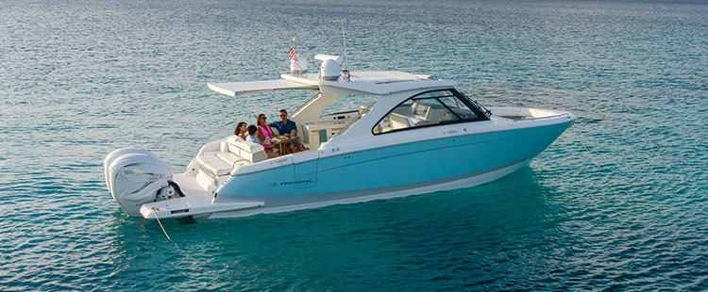

Project date: 2024-01-06

Hadeel Ghurab

Data Analytics

|  |  |
| --- | --- |
| Contents | Project description |
| Data sources |
| Data info |
| Data Profile |
| Data cleaning and Data consistency Checks |
| Visualizations |
| Limitations and challenges |
| Hypothesis |

# Project Description

The dataset comprises sales data for previously-owned boats available on a website where users can promote their used boats for sale. The website facilitates users in showcasing essential details about their boats, including manufacturing information, current condition, and the asking price. The marketing team has sought a sales analysis to prepare for a weekly newsletter. The primary goal of this analysis is to assist sellers by providing insights on enhancing engagement for their listed boats and staying informed about prevailing market trends.

# Data Sources

The data is sourced from Kaggle data repository. The dataset is one for the recommended dataset in the achievement brief.

Link: [Boat sales dataset](https://www.kaggle.com/datasets/karthikbhandary2/boat-sales/download?datasetVersionNumber=1) (<https://www.kaggle.com/datasets/karthikbhandary2/boat-sales/download?datasetVersionNumber=1>)

Upon login into to the Kaggle data source and downloading the the dataset the file comes encapsulated in a zip file on unzip the file the downloaded is boat_sales.csv

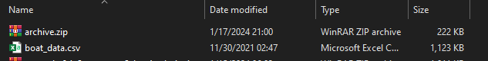

# Data info

The dataset focuses on gauging the popularity of boats, encompassing 10 informative columns. These columns provide comprehensive details about each boat, encompassing information such as the year of its construction, the boat's type, pricing details, and various other relevant attributes. In essence, the dataset offers a nuanced perspective on the boats' characteristics, facilitating a thorough analysis of their popularity and key features.

The dataset's detailed information on boat characteristics, including the year of construction, boat type, and pricing details, directly contributes to addressing and validating the hypothesis regarding the factors influencing boat popularity and market trends.

# Data profile

|  |  |  |  |  |  |  |  |  |
| --- | --- | --- | --- | --- | --- | --- | --- | --- |
| Category | Data Type | Description | Unique Values | Distribution |  |  |  |  |
| Price | Character | Represents the b | 3182 | Motor Yacht: 28%, Sport Boat: 14%, Other (5761): 58% | | | |  |
|  |  | in various currencies (e.g., EUR, £ | | ,Bénéteau power boats: 6%, Other (7919): 80% | | |  |  |
|  |  |  |  | Price Ranges: |  |  |  |  |
|  |  |  |  | 0.00 - 202.10: 551 listings | |  |  |  |
|  |  |  |  | 1818.90 - 2021.00: 9,337 listings | |  |  |  |
|  |  |  |  | 0: 2021 listings |  |  |  |  |
| Boat Type | Character | Represents the t | y 3 | Motor Yacht: 42%, Sport Boat: 17%, Other (4062): 41% | | | |  |
| Manufacturer | Character | Represents the m | 13 | Bénéteau: 55%, Other (2655): 27% | | |  |  |
| Type (Condition | &Character | Represents the c | 2 | Used boat, Diesel: 42%, Used boat, Unleaded: 17%, | | | |  |
|  |  | of engine (e.g., Diesel, Unleaded) | | Other (4062): 41% | |  |  |  |
| Year Built | Numeric | Represents the y | - | See provided labels and counts | |  |  |  |
| Length | Numeric | Represents the l | e- | See provided labels and counts | |  |  |  |
| Width | Numeric | Represents the w | - | See provided labels and counts | |  |  |  |
| Material | Character | Represents the m | 3 | GRP: 55%, Other (2655): 27% | |  |  |  |
| Location | Character | Represents the l | o 5 | Netherlands » In verkoophaven: 3%, Croatia (Hrvatska): 2%, Other (9335): 94% | | | | |
| Number of Views | Numeric | Represents the n | - | See provided labels and counts | |  |  |  |

# Data Cleaning and Data Consistency Checks

* Data Cleaning and Data Consistency Checks
* Adjust the data type
* Convert the prices to a single currency
* Extract the country and city from the location
* Check for missing data
* Check for duplicate data
* Check for mixed data type

# Visualizations

# Limitations

* Boat prices were displayed in different currencies, hindering straightforward price comparisons.
* Boat locations included the country and an inconsistent, imprecise location, lacking uniformity across all listings.

# Hypothesis

* Attributes of the boat listing with the highest viewership in the past 7 days
* What is the cost of the boat that garnered the highest number of views?
* Are there shared characteristics among the most frequently viewed boats?
* Where is the most viewed boat located?